CyPHERCRESCENT ACADEMY TEST PROJECT

DESIGN AND DEVELOPMENT APPROACH

Prepared by ALAPHER W. HEARTY

Document Control

|  |  |  |  |
| --- | --- | --- | --- |
| **Date** | **Version** | **Prepared by** | **Comments** |
| December 31, 2018 | 1.0 | ALAPHER W. HEARTY | Initial Draft |
|  |  |  |  |
|  |  |  |  |
|  |  |  |  |
|  |  |  |  |
|  |  |  |  |
|  |  |  |  |
|  |  |  |  |
|  |  |  |  |
|  |  |  |  |
|  |  |  |  |
|  |  |  |  |

## Table of Contents

Table of Contents 3

Database Configuration and Development Tools 4

Dependencies 4

Design and Development Approach 5

Interface Description 6

## INTRODUCTION

## This is a simple report narrating the design and development approach of this test project. I recommend the Visual Studio be run with administrative privileges should if the MS Access file is in read only or due to restrictions of some local Drive(s) where the operating system is installed on.

## Database Configuration and Development Tools

**Database Configuration**

This section considers the Database Management System Used in the development process.

* **Microsoft Access Database**

Name : Shape_db

NB: Cut the Shape_db file in the Database folder of the project folder and paste it in drive **C:\**

**Development Tools**

* Visual Studio 2017
* Microsoft Windows
* C#.Net Programming language

## Dependencies/Libraries

* Below packages are forcreating regions on the Shell, and adding the color picker to the toolbar

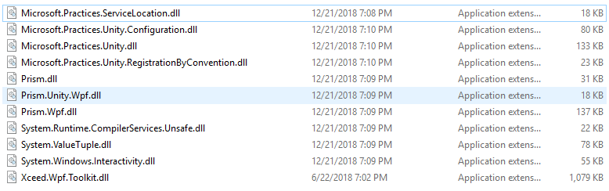

## DESIGN AND DEVELOPMENT APPROACH

## Design Patterns

## The following Software development patterns were adopted for the development of this test project

* Structural Pattern: Adapter Pattern, Decorator Pattern
* Behavioral Patterns: Strategy Pattern, Command Pattern, Observer Pattern etc.
* Creational Patterns: Singleton Pattern

## Development Approach

Object Oriented Development Approach was adopted to keep the implementation process of the test projectclean, easily maintainable and readable.

## Design Principle

## The SOLID principle which consists of the five design principles was implemented to make test project designs easily understandable

## GUI Descriptions

**Start Up Window**

* Application star up Window contains toolbar, Toolbox, drawing Canvas and Items Pane and
* The toolbox contain the shown WPF controls

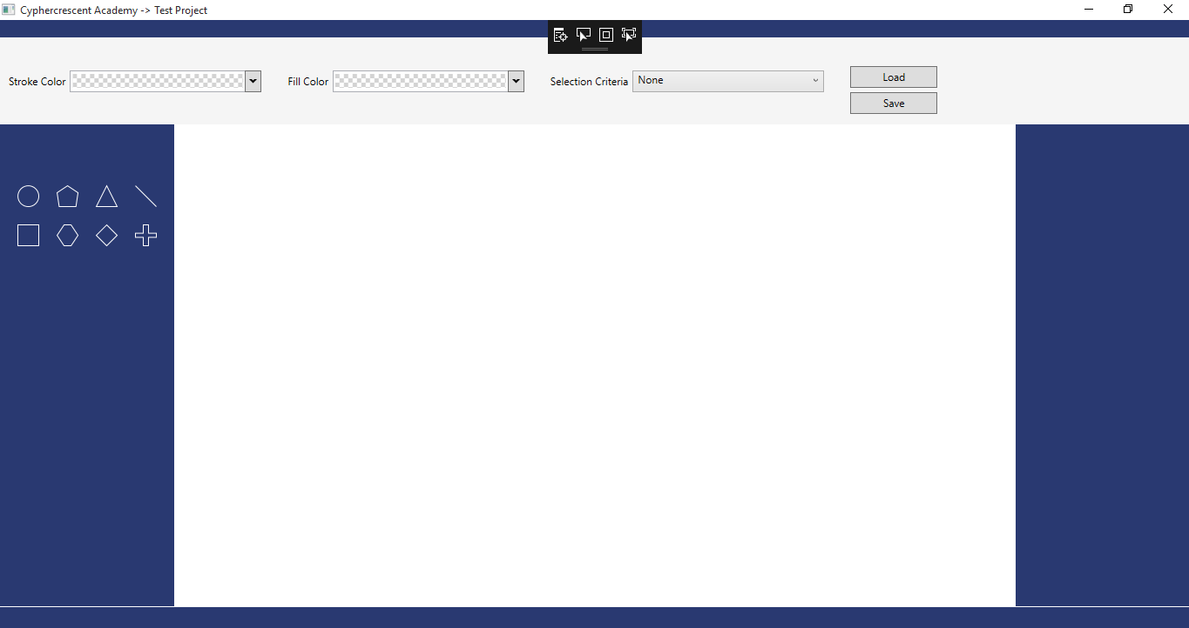

*Figure 1: Application Launch Window*

**DRAGGING SHAPES TO CANVAS**

* The user should be able to drag an item from the toolbox and place it on the drawing canvas. The selected item should be placed on the user’s drop location

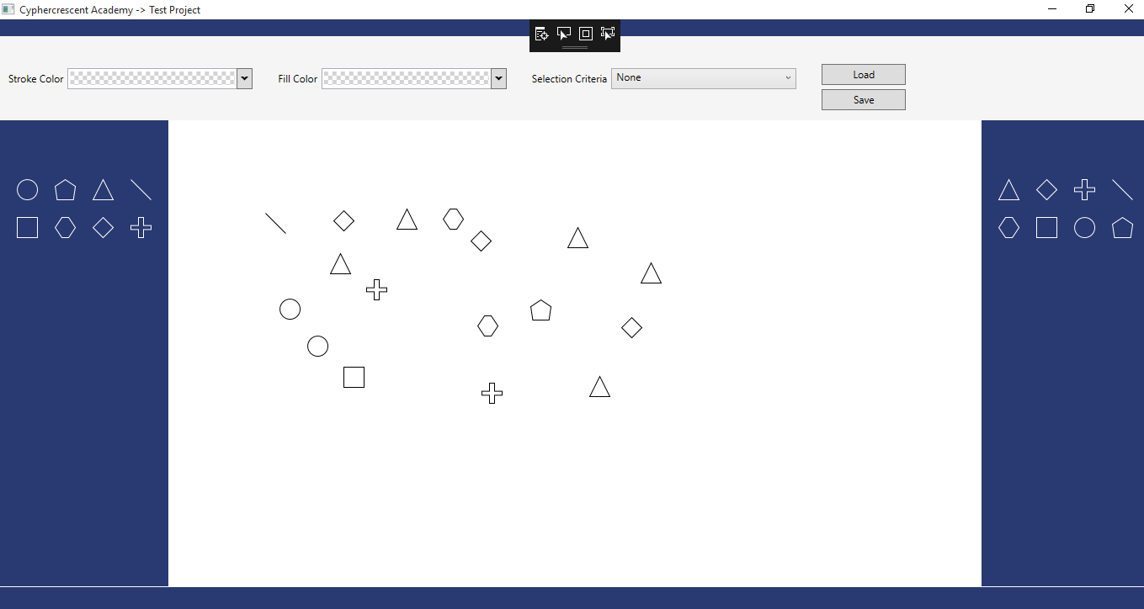 *Figure 2: Dragging Shapes to Drawing Canvas*

**BLUE COLOR HIGHLIGHTING ON A SELECTED SHAPE**

The enables the user to select any item on the canvas by clicking it, then a blue rectangle will appear around any selected item(s) and selected item(s) can also be dragged around the canvas.

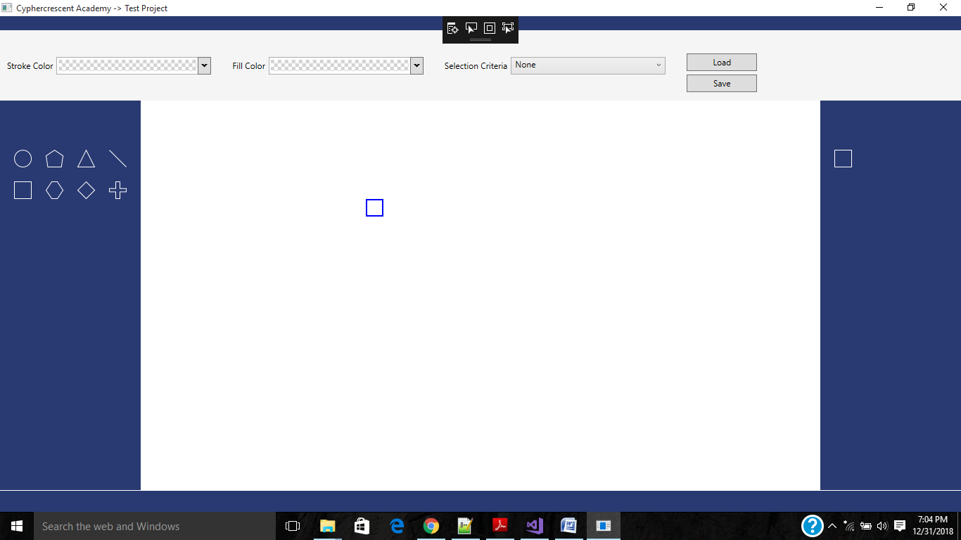

*Figure 3: Color Highlighting a Selected Shape(s)*

**STROKE COLOR**

The *Stroke Color* tool on the toolbar was used to change the border color of the selected item on the drawing canvas.

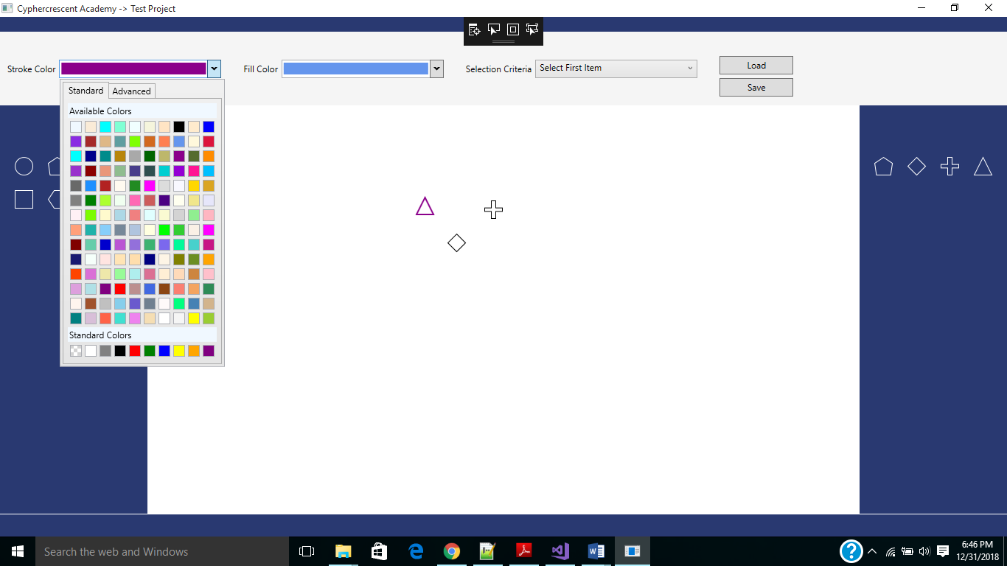

*Figure 4: Stroke Color Palette*

**FILL COLOR**

The *Fill Color* tool on the toolbar as shown below was used to change the fill color of the selected item(s) on the drawing canvas.

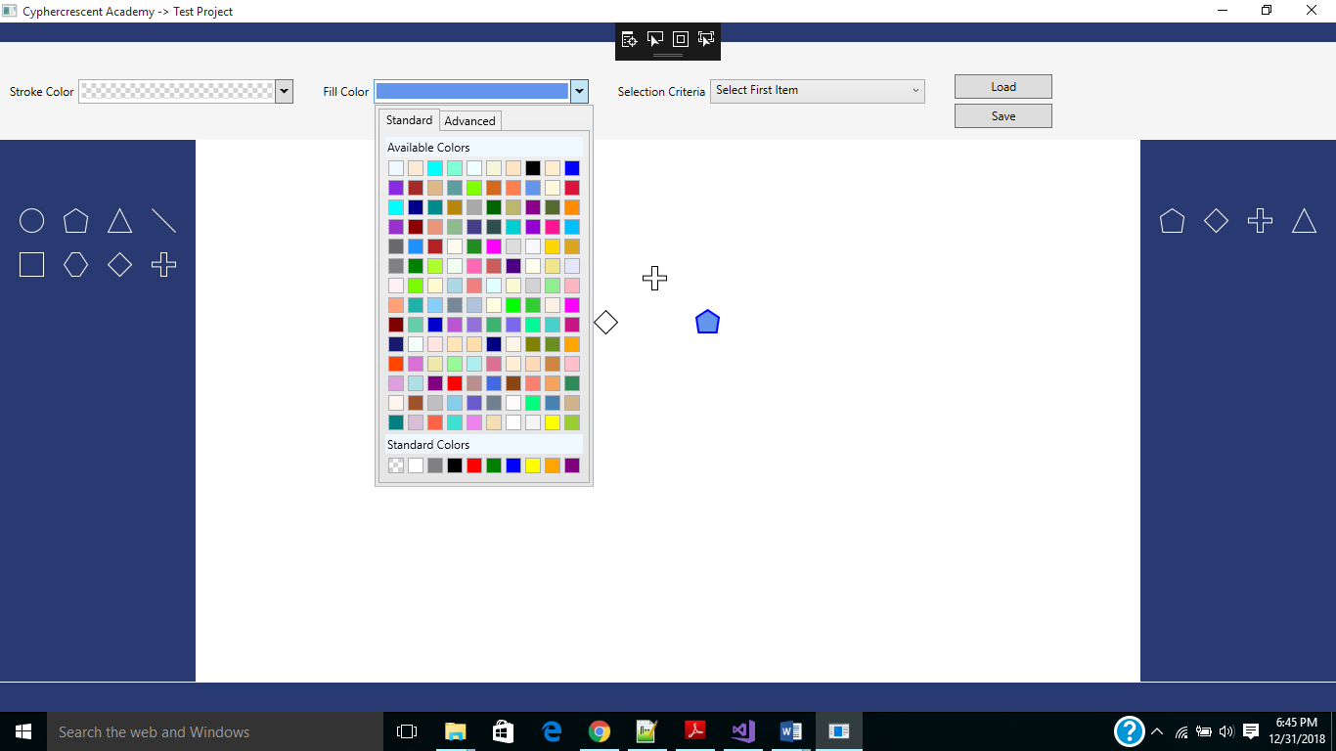 *Figure 5: Fill Color Palette*

**ITEMS PANE**

The *Items Pane* displays a list of shapes. A shape is only shown if it is present on the drawing canvas. Each shape was only displayed once on the ***Items Pane***irrespective of how many times it appears on the drawing canvas.

*Figure 6: Distinct Shapes on the Drawing Canvas*

SELECT FIRST ITEM

A user can select several items on the drawing canvas by selecting the appropriate shape on the *Items Pane* and selecting an option from the *Selection Criteria* tool on the toolbar as shown in Figure below. Select first item: When this option is active, the first item of the selected shape that was dropped on the drawing canvas is selected.

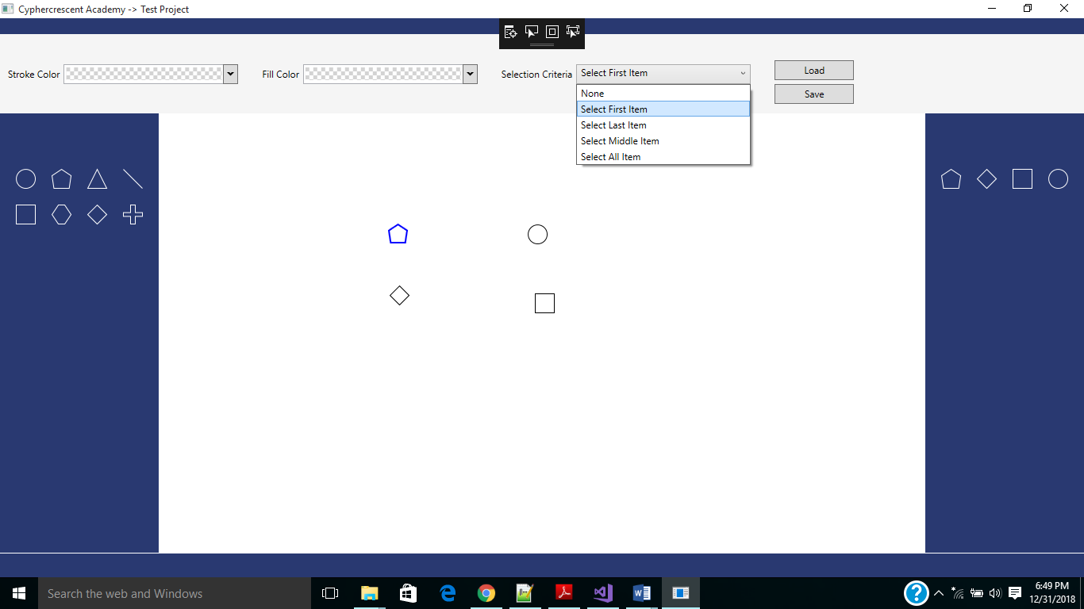

*Figure 7: Select First Item Criterion*

**SELECT LAST ITEM**

When this option is active, the last item of the selected shape that was dropped on the drawing canvas is selected

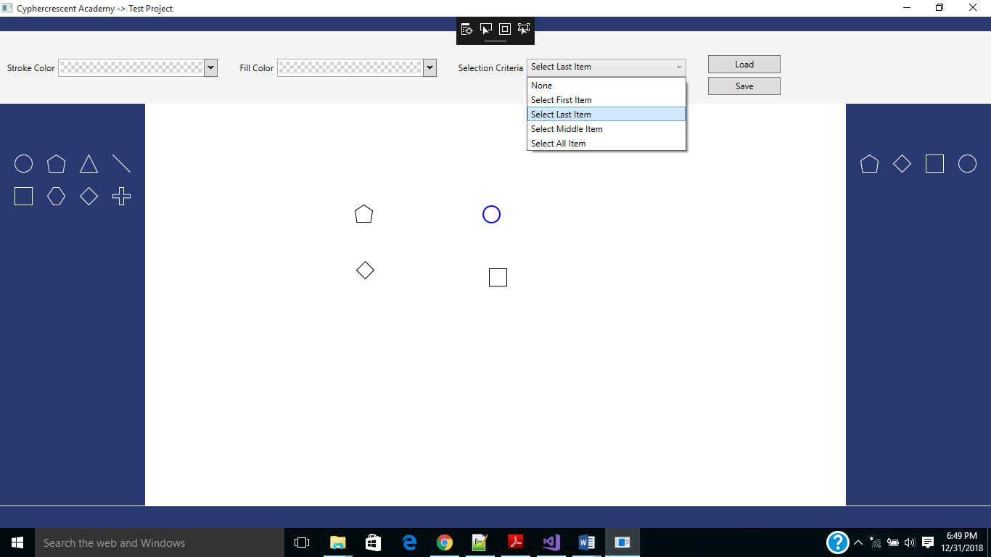 *Figure 8: Select Last Item Criterion*

**MIDDLE ITEM**

When this option is active, the middle item of the selected shape on the drawing canvas is selected

If the total number of the selected shape is even, two shapes should be selected. If the total number of the selected shape is odd, one shape will be selected

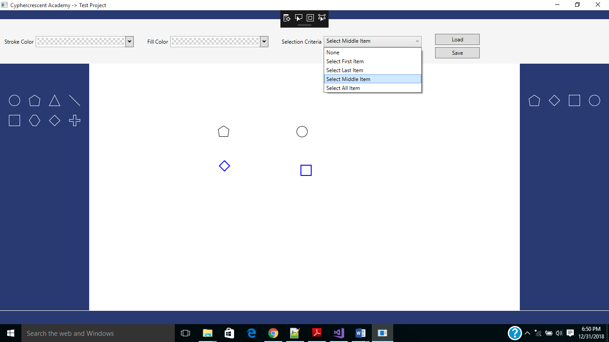

*Figure 9: Select Middle Item Criterion*

**SELECT ALL ITEMS**

When this option is active, all items of the selected shape on the drawing canvas are selected

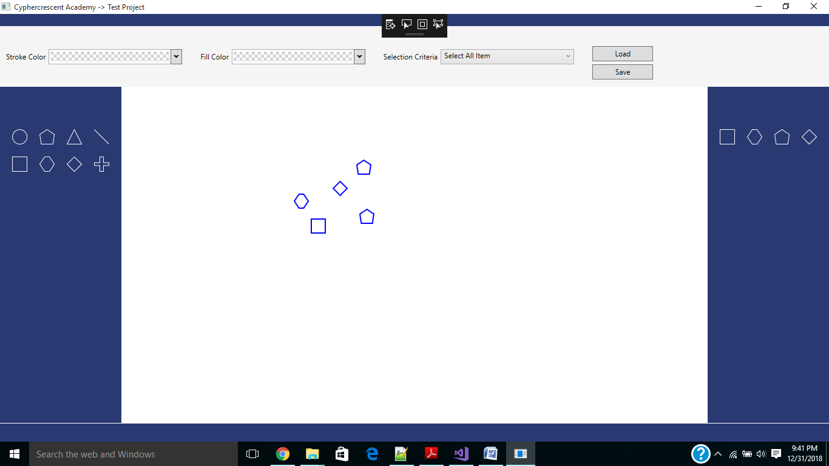

*Figure 10: Select All Items Criterion*

**SAVE ITEMS**

A user can save the drawing by clicking the ‘Save’ button. When this happens, the current drawing is saved to a local MS Access database.

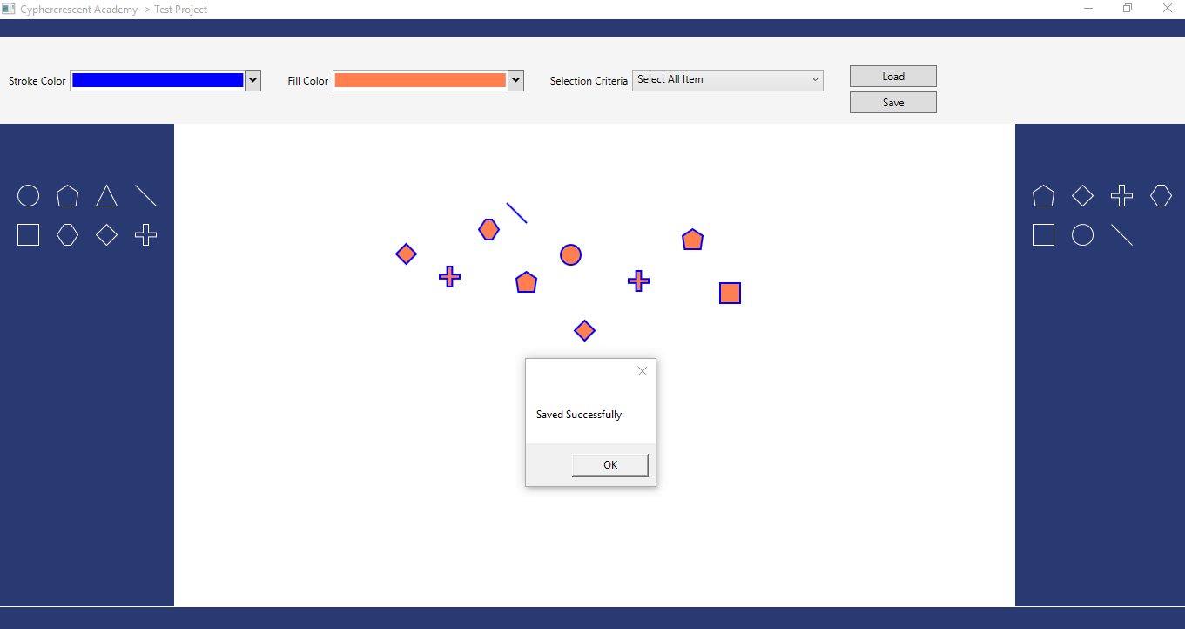

*Figure 11: Save items on the Drawing Canvas to MS Database*

**LOAD**

A user can load a saved drawing by clicking the ‘*Open’* button and selecting an MS Access file using the file dialog

